the title of the paper, maximum three lines, Style: naslov rada
Name and surname of author, author, author... (Style: Imena autora)
Summary: (Style: Rezime-naslov)
This template has been prepared in the format to be used for papers to be published in the Proceedings of the 16th International Scientific Conference iNDiS 2023 – Planning, design, construction and building renewal. Summary text should contain minimum 8 and maximum 12 lines (Style: Rezime-tekst). The objective, main results and conclusions of the paper should be briefly stated. The Title and the Summary in Serbian and English should remain on the first page of the paper. Information about authors should be written in the footnote. Summary text should contain minimum 8 and maximum 12 lines (Style: Rezime-tekst). The objective, main results and conclusions of the paper should be briefly stated. The Title and the Summary in Serbian and English should remain on the first page of the paper. Information about authors should be written in the footnote.
Key words: maximum 6 key words (Style: Ključne reči)
NASLOV RADA, maksimalno tri reda, Stil: naslov rada
Rezime: (Stil: Rezime-naslov)
Ovo uputstvo je pripremljeno u formatu koji se koristi za radove koji će biti objavljeni u Zborniku radova 16. Međunarodne naučne konferencije iNDiS 2023 – Planiranje, projektovanje, izvođenje i obnova graditeljstva. Tekst Rezimea treba da sadrži najmanje 8 i najviše 12 redova (Stil: Rezime-tekst). U tekstu Rezimea ukratko dati cilj, glavne rezultate i zaključke rada. Naslov rada i tekst Rezimea na srpskom i engleskom jeziku treba da ostanu na prvoj strani rada. U fusnoti prve strane navesti podatke o autorima. Tekst Rezimea treba da sadrži najmanje 8 i najviše 12 redova (Stil: Rezime-tekst). U tekstu Rezimea ukratko dati cilj, glavne rezultate i zaključke rada. Naslov rada i tekst Rezimea na srpskom i engleskom jeziku treba da ostanu na prvoj strani rada. U fusnoti prve strane navesti podatke o autorima.
Ključne reči: najviše 6 ključnih reči (Stil: Ključne reči (Times New Roman, 12pt, italic, 8pt after))

introduction (Style: Heading 1)
The first Chapter of the paper begins on the second page. Minimum number of pages is 6. Style Rad-tekst should be used for the paper body text.
The size of the paper is A4 (210x297mm) with margins: Left 30mm, Right 30mm, Top 10mm, Bottom 10mm and Gutter 0mm. Blank lines should not be inserted between headings and paragraphs.

title of subchapter LEVEL 1 (Style: heading 2)
If the footnote is applied, use command References/Insert Footnote, example.

Title of Subchapter level 2 (Style: Heading 3)
Bullets in the text should be written in Style Nabrajanje:
- first item,
- second item,
- third item.

Title of Subchapter level 2 (Style: Heading 3)
If there are formulas, they should be written in Style Jednačina and inserted as Insert/Equation:
$$A=πr^{2}$$ | (1)
For text in tables, use Style Tabela-tekst.
Tab. 1 The title of the table should be written in Style Naslov Tabele
item number | M_{x} [kNm]
1
2

One line should be left between the table and the body text in Style Rad-tekst.
One line should be left between the table and the image in Style Rad-tekst.
One line should be left between the body text and the image in Style Rad-tekst.

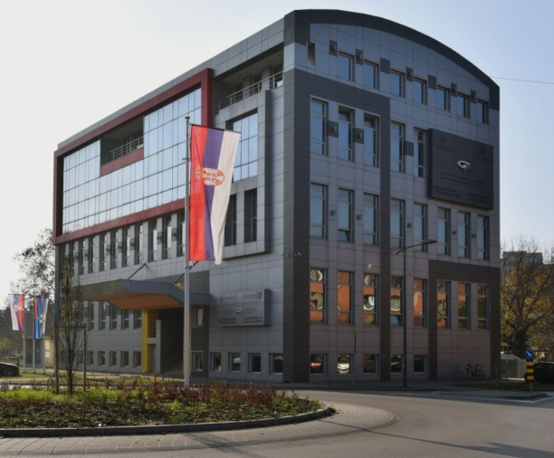
Fig. 1 The title of the image should be written in Style Naslov Slike
Figures should be placed near to their first mention in the body text. Minimum resolution of figures should be 300 dpi. Allowed formats are JPEG, PNG and TIFF.

chapter (Style: Heading 1)

title of subchapter LEVEL 1 (Style: heading 2)
Paper should be prepared in digital form and submitted as both a PDF version in High Quality Print and as a Word file (2003 or later versions), until the deadline stated on the Conference website https://indis.gradjevinans.net. The paper should be submitted via EasyChair system. Access link: https://easychair.org/conferences/?conf=indis2023.
The paper file should be named as follows: iNDiS2023_Last name of the first author_Paper ID (e.g. iNDiS2023_Dzolev_012). The Paper ID will be provided on the confirmation on acceptance of the abstract.
At least one of the authors must register and pay his/her registration fee in order for the paper to be included in the Proceedings and in the final programme of the Conference.

acknowledgement (Style: zahvalnost)
The text in the Acknowledgment section should be written in Style Zahvalnost-tekst.

references (Style: LITERATURA)
Text in References should be written in Style Literatura-tekst. Each reference cited in the body text should also be presented in the reference list and vice versa, by the order of appearance. Commercial papers or documents not available to the public should not be referenced. Include the digital object identifier (DOI) for all references where available. Following are given examples of References presentation for a journal article, book, conference proceedings paper and doctoral dissertation, respectively.
- Xie J., Fu Q., Yan J. (2019). Compressive behaviour of stub concrete column strengthened with ultra-high performance concrete jacket. Construction and Building Materials, Volume 204, pp. 643–658. https://doi.org/10.1016/j.conbuildmat.2019.01.220.
- Crank J. (1975). The Mathematics of Diffusion. 2nd ed., Clarendon Press, Oxford, Great Britain.
- Kusunoki K., Yeow T., Kajiwara K. (2021). Tackling earthquake disaster by using E-defense shaking table facility. 15th International Scientific Conference iNDiS – Planning, Design, Construction and Building Renewal, Faculty of Technical Sciences, Novi Sad, Serbia, 24-26 November, pp. 32–43.
- Hozjan T. (2009). Nelinearna analiza vpliva požara na sovprežne linijske konstrukcije. Doctoral thesis (in Slovenian), University of Ljubljana, Slovenia.

Title, organization, city, contry, e-mail of the author (Style: Fusnota-tekst)
Assoc. prof., Faculty of Technical Sciences, University of Novi Sad, Serbia, username@uns.ac.rs
Engineer, Company, Novi Sad, Serbia, info@company.rs
Style: Fusnota-tekst

