paper title, maximum three lines (Style: naslov rada)
Name and surname of the author, author, author... (Style: Imena autora)
Summary: (Style: Rezime-naslov)
This template has been prepared in the format for papers which will be published in the Proceedings of the 17th International Scientific Conference iNDiS 2026 – integration, Novelty, Design, interdisciplinarity, Sustainability. The Title, Summary, and Keywords in Serbian and English should remain on the first page of the paper. Summary text should contain minimum 8 and maximum 12 lines (Style: Rezime-tekst). The objective, main results, and conclusions of the paper should be briefly stated. Information about authors should be written in the footnote. ORCID identification should be provided at least for the first author.
Keywords: maximum 6 keywords (Style: Ključne reči)
NASLOV RADA, maksimalno tri reda (Stil: naslov rada)
Rezime: (Stil: Rezime-naslov)
Ovaj šablon pripremljen je u formatu za radove koji će biti objavljeni u Zborniku radova 17. međunarodne naučne konferencije iNDiS 2026 – integration, Novelty, Design, interdisciplinarity, Sustainability. Naslov rada, Rezimea i Ključnih reči na srpskom i engleskom jeziku treba da ostanu na prvoj strani rada. Tekst Rezimea treba da sadrži najmanje 8, a najviše 12 redova (Stil: Rezime-tekst). U tekstu Rezimea ukratko dati cilj, glavne rezultate i zaključke rada. U fusnoti prve strane treba navesti podatke o autorima. Barem za prvog autora neophodno je navesti ORCID identifikaciju.
Ključne reči: najviše 6 ključnih reči (Stil: Ključne reči)

introduction (Style: Heading 1)
The first Chapter of the paper starts on the second page. Minimum number of pages is 6. Style Rad-tekst should be used for the paper body text.
The size of the paper is A4 (210 x 297mm) with margins: Left 30 mm, Right 30 mm, Top 10 mm, Bottom 10 mm and Gutter 0 mm. Blank lines should not be inserted between headings and paragraphs.

title of subchapter LEVEL 1 (Style: heading 2)
If the footnote is applied, use command References/Insert Footnote, example.

Title of Subchapter level 2 (Style: Heading 3)
Bullets in the text should be written in Style Nabrajanje:
- first item,
- second item,
- third item.

Title of Subchapter level 2 (Style: Heading 3)
If there are formulas, they should be written in Style Jednačina and inserted as Insert/Equation:
$$A=πr^{2}$$ | (1)
For text in tables, use Style Tabela-tekst.
Tab. 1 The title of the table should be written in Style Naslov Tabele
item number | M_{x} [kNm]
1
2

One line should be left between the table and body text in Style Rad-tekst.
One line should be left between the table and image in Style Rad-tekst.
One line should be left between the body text and image in Style Rad-tekst.

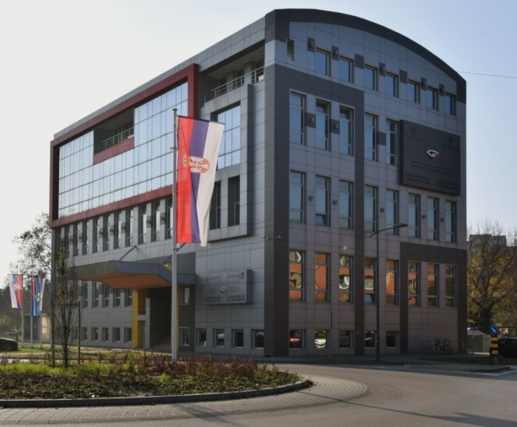
Fig. 1 The title of the image should be written in Style Naslov Slike
Figures should be placed near to their first mention in the body text. Minimum resolution of figures should be 300 dpi. Allowed formats are JPEG, PNG, and TIFF.

chapter (Style: Heading 1)

title of subchapter LEVEL 1 (Style: heading 2)
Paper should be prepared in digital form, as a Word file (version 2003 or newer), and should be submitted before the deadline indicated on the Conference website https://indis.gradjevinans.net. The paper should be submitted via EasyChair system. Access link: https://easychair.org/conferences/?conf=indis2026.
The paper file should be named as follows: iNDiS2026_Last name of the first author_First keyword (e.g. iNDiS2026_Dzolev_Fire).
At least one of the authors must register and pay a registration fee in order for the paper to be included in the Proceedings and in the final programme of the Conference.

acknowledgement (Style: zahvalnost)
Text in the Acknowledgement section should be written in Style Zahvalnost-tekst.

references (Style: LITERATURA)
Text in References should be written in Style Literatura-tekst. Each reference cited in the body text should also be presented in the reference list and vice versa, according to the order of appearance. Commercial papers or documents not available to the public should not be referenced. Where possible, include the DOI. Examples of referencing a journal article, book, conference paper and doctoral dissertation, respectively, are provided below.
- Xie J., Fu Q., Yan J. (2019). Compressive behaviour of stub concrete column strengthened with ultra-high performance concrete jacket. Construction and Building Materials, Volume 204, pp. 643–658. https://doi.org/10.1016/j.conbuildmat.2019.01.220
- Crank J. (1975). The Mathematics of Diffusion (2nd edition), Clarendon Press, Oxford, Great Britain.
- Kusunoki K., Yeow T., Kajiwara K. (2021). Tackling earthquake disaster by using E-defense shaking table facility. 15th International Scientific Conference iNDiS – Planning, Design, Construction and Building Renewal, Faculty of Technical Sciences, Novi Sad, Serbia, 24-26 November, pp. 32–43.
- Hozjan T. (2009). Nelinearna analiza vpliva požara na sovprežne linijske konstrukcije. Doctoral thesis (in Slovenian), University of Ljubljana, Slovenia. http://drugg.fgg.uni-lj.si/777/, accessed on 12 December 2024.

Title, organization, city, contry, e-mail of the author, ORCID identifier (Style: Fusnota-tekst)
Assoc. Prof., Faculty of Technical Sciences, University of Novi Sad, Novi Sad, Serbia, username@uns.ac.rs, ORCID xxxx-xxxx-xxxx-xxxx
Engineer, Company, Novi Sad, Serbia, info@uns.ac.rs, ORCID xxxx-xxxx-xxxx-xxxx
Style: Fusnota-tekst

